-

‘The Library Catalogue’ – Account setup

- Access Khalifa University Webpage: http://www.kustar.ac.ae

- Click on ‘login’, then ‘Library Account’
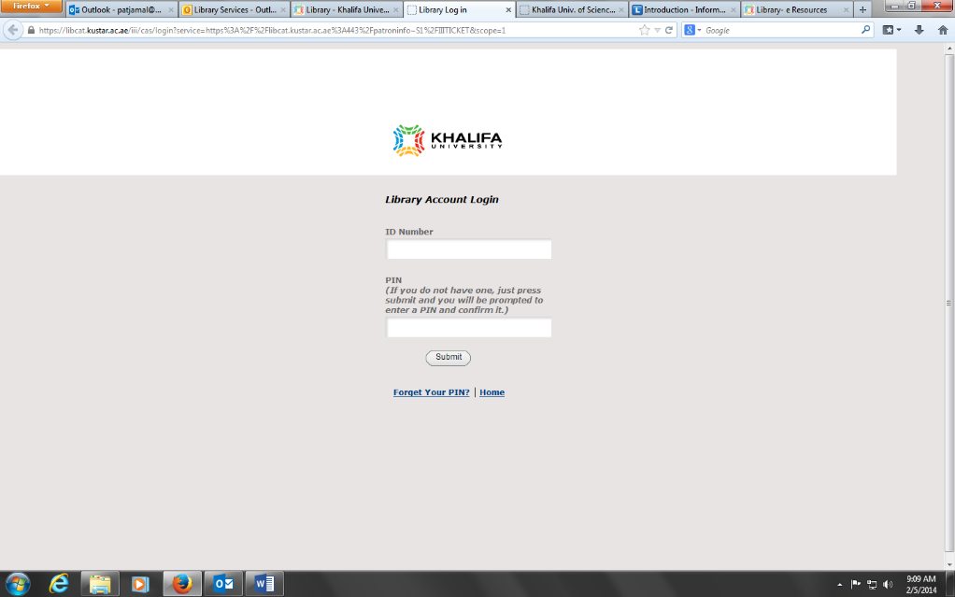
- Type in your ID number in the ID number field and click on ‘submit’. The next page will prompt you to enter a PIN. The PIN should be alpha-numeric. Remember your pin!

- You can renew any items you have out on loan, put a hold on a book that is checked out, change your PIN, save lists of searches, etc…

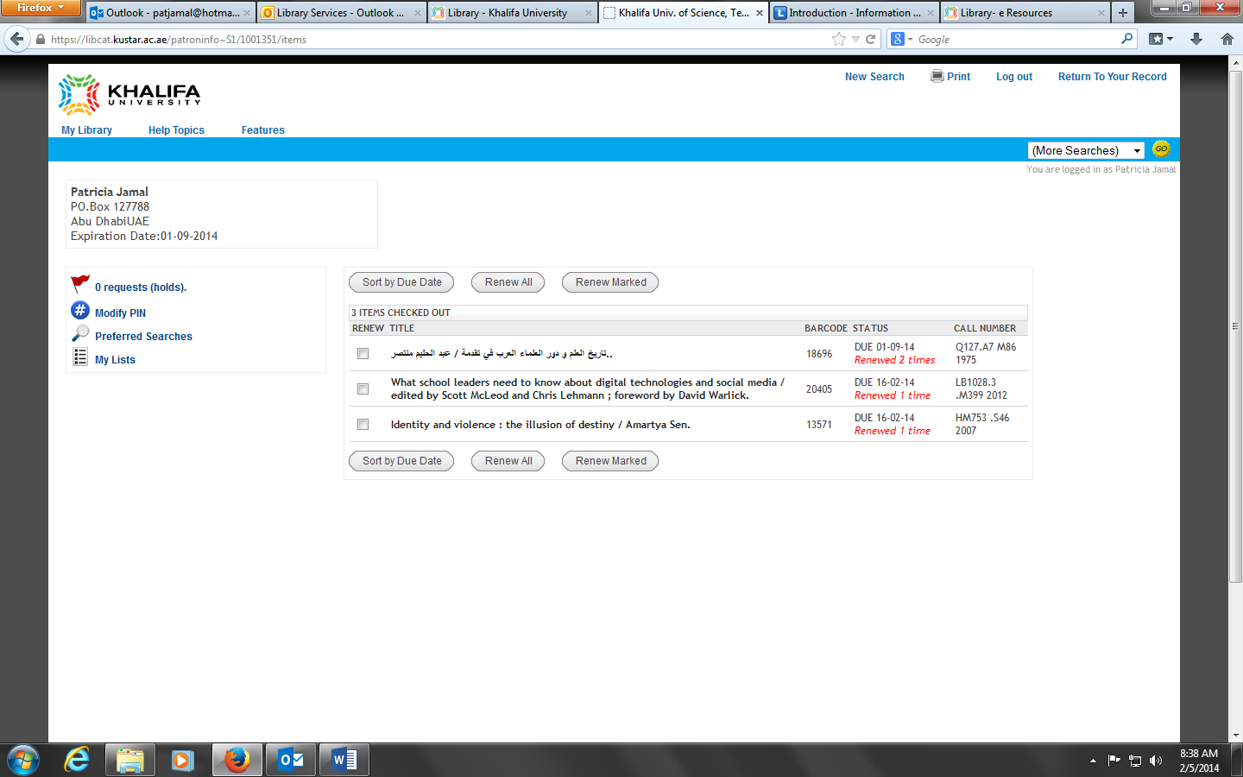

- Another way to login to your Library account:
  - Go to Khalifa University Webpage http://www.kustar.ac.ae
  - Click on Library
  - Click on Search Catalog Only
  - Click on Login

Note: If you need to reset your password for any reason, please contact the library staff by email, phone or come visit us in the Library.

